Algorithm Info

201533630김광륜

Program description.

1. Select day
2. Select Time
3. Select subway line
4. Then You can take your subway line congestion.
5. Machine learning previous finish.

DB 과정

1. db 생성

create database algorithm;

2. table 생성

create table line_total (

date varchar(20),

day varchar(10),

station_num integer,

5_6 integer,

6_7 integer,

7_8 integer,

8_9 integer,

9_10 integer,

10_11 integer,

11_12 integer,

12_13 integer,

13_14 integer,

14_15 integer,

15_16 integer,

16_17 integer,

17_18 integer,

18_19 integer,

19_20 integer,

20_21 integer,

21_22 integer,

22_23 integer,

23_24 integer,

24_ integer);

3. data 넣기

load data infile 'C://sample_data//line.csv' into table line_total fields terminated by ',';

***show variables like "secure_file_priv";

이걸로 file 경로 보기! 지정되어있지 않으면 my.ini파일 찾아서 변경

secure-file-priv="C://sample_data" 로 변경

JDBC JAR

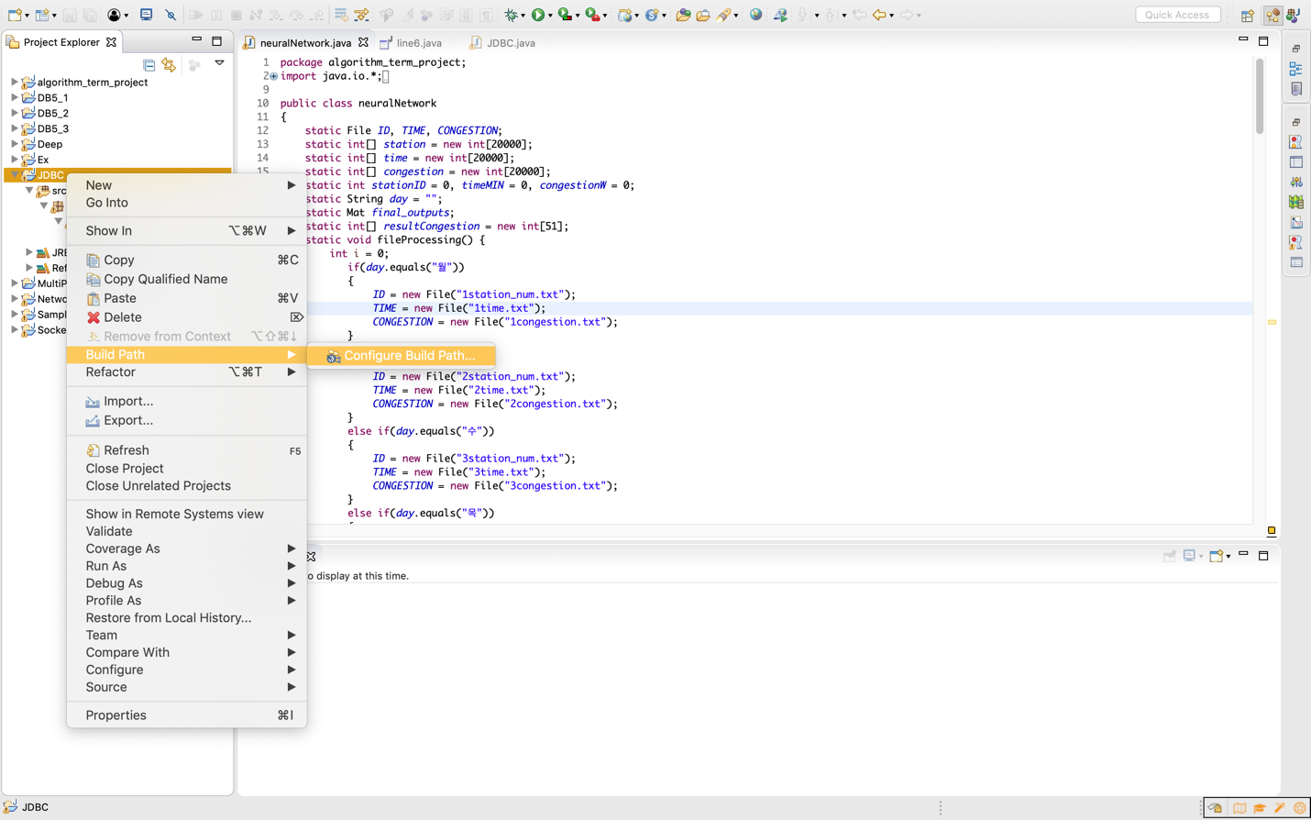

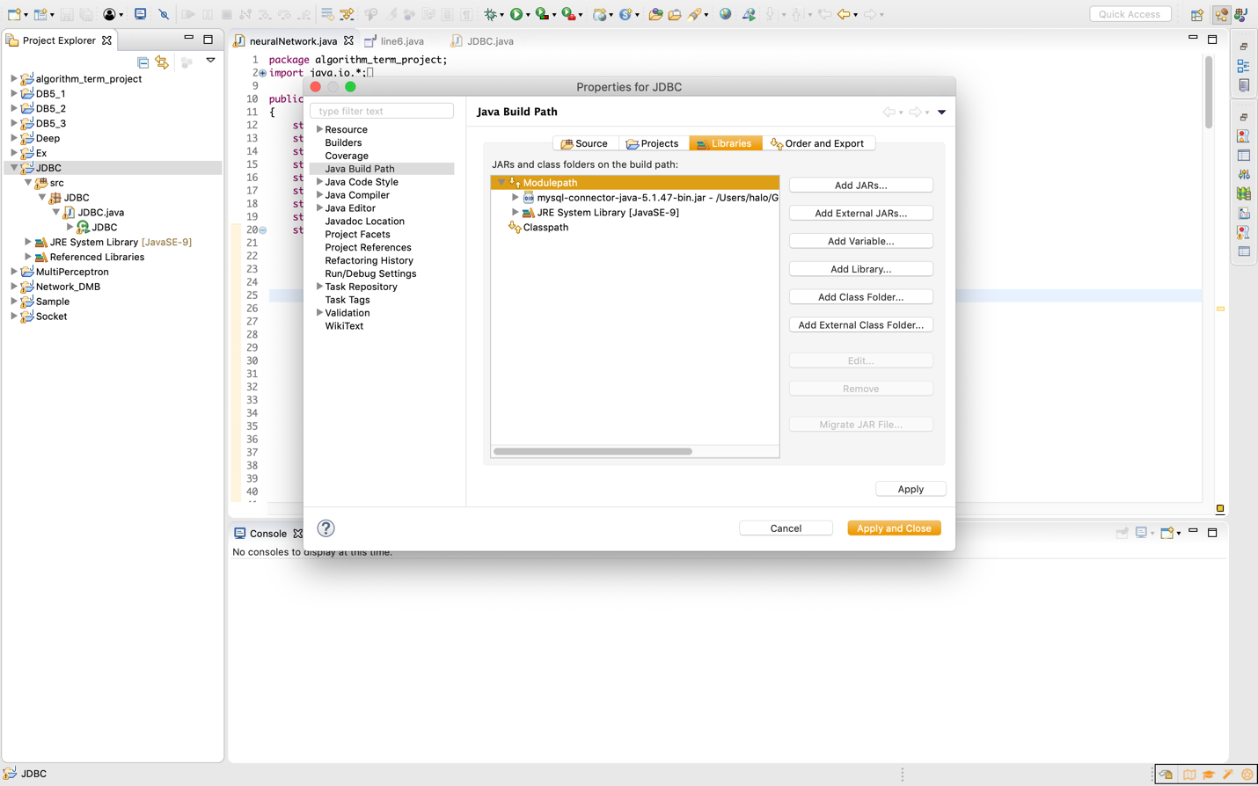

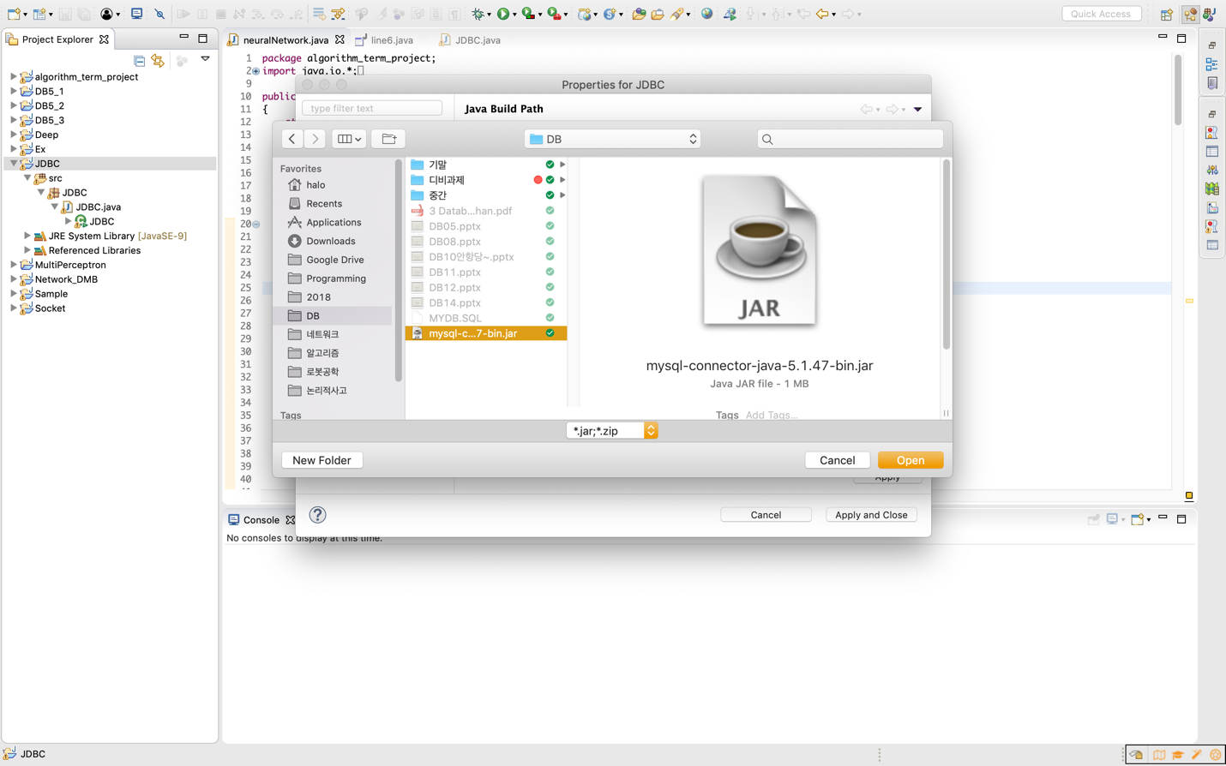

Neural Net JAR

